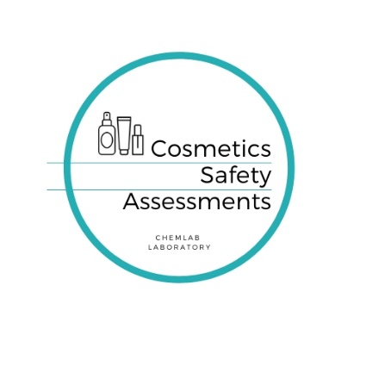


APPENDIX – COSMETIC PRODUCT SAFETY REPORT
DETAILS OF THE RESPONSIBLE PERSON
Company name / address / contact details / mail
DETAILS OF THE COSMETIC PRODUCT
Cosmetic Name
Type of product – Please fill “X” in one cosmetic category. If product belong to more than one category, for each category You need to do the safety report |  | Nail Product |  |  |  | ☐
 |  | Deodorant without alcohol |  |  |  | ☐
 |  | Deodorant with alcohol |  |  |  | ☐
 |  | Deodorant, non spray (roll-on or stick) |  |  |  | ☐
 |  | Perfume spray |  |  |  | ☐
 |  | Liquid soap |  |  |  | ☐
 |  | Solid soap |  |  |  | ☐
 |  | Face cleanser |  |  |  | ☐
 |  | Body cleanser/shower gel |  |  |  | ☐
 |  | Body cleanser/ bath oil, salt, etc. |  |  |  | ☐
 |  | Foot cleanser |  |  |  | ☐
 |  | Body and face cleanser |  |  |  | ☐
 |  | Body and hand cleanser |  |  |  | ☐
 |  | Body care |  |  |  | ☐
 |  | Face care |  |  |  | ☐
 |  | Body and face care |  |  |  | ☐
 |  | Body and hand care |  |  |  | ☐
 |  | Foot care |  |  |  | ☐
 |  | Hand care |  |  |  | ☐
 |  | Eye cream |  |  |  | ☐
 |  | Make -up remover |  |  |  | ☐
 |  | Liquid foundation |  |  |  | ☐
 |  | Eye shadow |  |  |  | ☐
 |  | Mascara |  |  |  | ☐
 |  | Eyeliner |  |  |  | ☐
 |  | Lip product |  |  |  | ☐
 |  | Sun care product |  |  |  | ☐
 |  | For mucous membrane contact |  |  |  | ☐
 |  | Beard stylization product |  |  |  | ☐
 |  | Beard cleanser |  |  |  | ☐
 |  | Depilation cream |  |  |  | ☐
 |  | Intimate hygiene product |  |  |  | ☐
 |  | Shaving product |  |  |  | ☐
 |  | After shaving product |  |  |  | ☐
 |  | Tooth paste |  |  |  | ☐
 |  | Mouthwash |  |  |  | ☐
 |  | Face mask |  |  |  | ☐
 |  | Hair Shampoo |  |  |  | ☐
 |  | Hair conditioner |  |  |  | ☐
 |  | Hair styling product |  |  |  | ☐
 |  | Henna for eyelash and eyebrows |  |  |  | ☐
 |  | Semi-permanent hair dye |  |  |  | ☐
 |  | Permanent hair dye |  |  |  | ☐
Product appearance (solid, liquid, paste, powder etc.)
Product color
Product fragrance
Product Leave on or Rinse off
Product imported to UE |  |  |  | Yes ☐ | No ☐
Country of Origin
Product for children under 3 year old |  |  |  | Yes ☐ | No ☐
Expire time |  |  | PAO
Information about packaging

COSMETIC FORMULA
L.P. | INGREDIENT TRADE NAME | INGREDIENT INCI NAME | CONCENTRATION (%)
1
2
3
4
5
6
7
8
9
10
11
12
13
14
15
16
17
18
19
20

For fragrance or essential oil please send IFRA document (It is necessary to prepare safety report)

